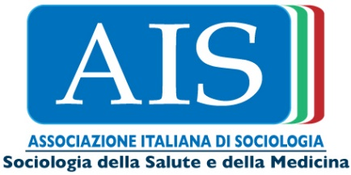

25 marzo 2019, ore 15.00
Aula Poeti
Strada Maggiore 45 - Bologna

Conferenza
Kristin Barker, Professor of Sociology, University of New Mexico (visiting fellow ISA, Dipartimento di Sociologia e Diritto dell’Economia, Università di Bologna)
The Social Construction of Illness (In a Mediate World)
The social construction of illness is a major research area in the subfield of medical sociology. For well over of a half-century, social constructionist approaches have significantly contributed to our understanding of the social dimensions of illness. I begin this talk by presenting three core social constructionist findings in medical sociology. Next, I point out how these foundational insights were largely formulated prior to one of the most significant social transformations of our time; namely, the expansion of the Internet and digital technologies. The methodological and theoretical approaches of social constructionism in medical sociology are, at least to some extent, anachronist in light of our increasingly mediated society. However, social constructionism has proven itself to be readily adaptable to these transformations, and scholars working in this area continue to provide robust accounts of the social dimensions of illness in our digital society. I present some of the substantive, methodological and theoretical contributions of current medical sociological research in this area, including some from my own research.

Saluti del Direttore del Dipartimento di Sociologia e Diritto dell’Economia: Marco Castrignanò

Introduce: Antonio Maturo (Università di Bologna, Dipartimento di Sociologia e Diritto dell’Economia)

Ne discutono: Mario Cardano (Università di Torino), Guido Giarelli (Università Magna Graecia di Catanzaro), Giuseppina Pellegrino (Università della Calabria), Roberta Sassatelli (Università Statale di Milano).

